**FOR IMMEDIATE RELEASE**

**GLIDERS OVER HOLLYWOOD**

***AIRSHIPS, AIRPLAY, AND THE ART OF ROCK PROMOTION***

**PAUL RAPPAPORT**

**Coming soon from Jawbone: a legend of music promotion gives a dynamic insider’s account of the golden age of rock, sharing never-before-told tales of his adventures with some of music’s most colourful characters, including The Rolling Stones, Bruce Springsteen, Pink Floyd, Bob Dylan, and many more. On sale April 1st, 2025.**

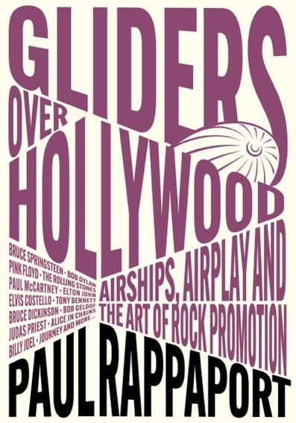

***Gliders Over Hollywood* tells the exhilarating true story of a blue-collar kid nicknamed ‘Rap’ who grew up in thrall to rock’n’roll, then found himself right in the middle of many of his heroes’ lives as he became the most renowned rock promotion man in the USA.**

Paul Rappaport enjoyed a storied thirty-three-year career at Columbia Records, where he was instrumental in the careers of everyone from Bob Dylan to Bruce Springsteen, Pink Floyd to The Rolling Stones, Elvis Costello to Billy Joel, Judas Priest to Alice In Chains, and many, many more.

The music business from the late 60s through the 90s was an exciting time that mirrored the music and the musicians making it. It was also a time of new and creative ideas on how to market this groundbreaking cultural phenomenon. Eccentric characters were everywhere, and often the managers, promoters, disc jockeys, and record company staff were just as big a show as the performers themselves.

‘I wrote this book to capture the magical times,’ says Paul, ‘so that people wouldn’t forget but also to show the many behind-the-scenes folks whose lives were so colorful they brought a warmth and laughter to the world. If you want to know what it felt like to be there, to experience the whole scene first hand, to get the inside track on how it really all went down, these stories are for you. I welcome you to follow me down the rabbit hole to a magical place that will bring you laughter and reveal the inner workings of the music biz that you may have often wondered about.’

From creating the Pink Floyd airship to sword-fighting with Bruce Dickinson of Iron Maiden and receiving a guitar lesson from Keith Richards, *Gliders Over Hollywood* is packed full of extraordinary adventures with some of the biggest names in rock.

**About the author**

**Paul Rappaport** was senior vice-president of rock promotion at Columbia Records, where he enjoyed a thirty-three-year career playing a pivotal role in the careers of some of the biggest stars in the business. He co-created and executive produced the Emmy Award-winning music television series *A&E’s Live By Request* and the popular live radio series *The Columbia Records Radio Hour*. Upon leaving Columbia, he formed his own production company, Tres Hombres, and for many years wrote the ‘Backstage Access’ blog for *Classics Du Jour*. He was the lead guitarist in the pioneering LA punk band Mogan David & His Winos. *Gliders Over Hollywood* is his first book. He lives in Port Washington, New York.

**Advance praise**

‘So, you want to work in the music business? How much do you know about it? The answer is clearly not enough—no one in their right mind could countenance such a career! But if you must, then you need this book. Rapper was there. Not only that, but he remembers most of the detail, which is more than can be said for his subjects, who have a tendency to rewrite history as they would have liked it or justify actions that should have put them in jail. It’s about as close as you can get to the action without having that gold Access All Areas pass.’ **Nick Mason, Pink Floyd**

‘It took an essential symbiosis of artists, record companies and radio to make the musical memories we all hold dear. Without Paul’s personal creativity, energy, and enthusiasm, the Blue Öyster Cult would never have reached the audience and endurance it has. It’s the same for every artist he connected with!’ **Buck Dharma, Blue Öyster Cult**

‘The depth and thoughtfulness of Paul’s approach to promotion should be a lesson to every would-be music person, regardless of what avenue they pursue. This should be required reading in every college music business program.’ **Mark Spector, manager—Joan Baez, Graham Nash, and more**

‘I am beside myself and beyond words that Paul has written this book. He's The Inventor Of Rapp, you know.’ **Elvis Costello**

**Review copies available on request. Author available for interview.**

For US press and publicity, please contact Wendy Brynford-Jones: wendy@hellowendy.com

For UK press and publicity, please contact Ben Pester: ben@pesterpr.co.uk

For all other enquiries, please email books@jawbonepress.com

**GLIDERS OVER HOLLYWOODby PAUL RAPPAPORT**

Published April 1st, 2025, by Jawbone Press (www.jawbonepress.com)

344pp softcover with 24pp plate insert

ISBN 9781916829183 / £16.95 UK / $24.95 US / $32.95 CAN