JOHN McCUTCHEON AND TOM PAXTON
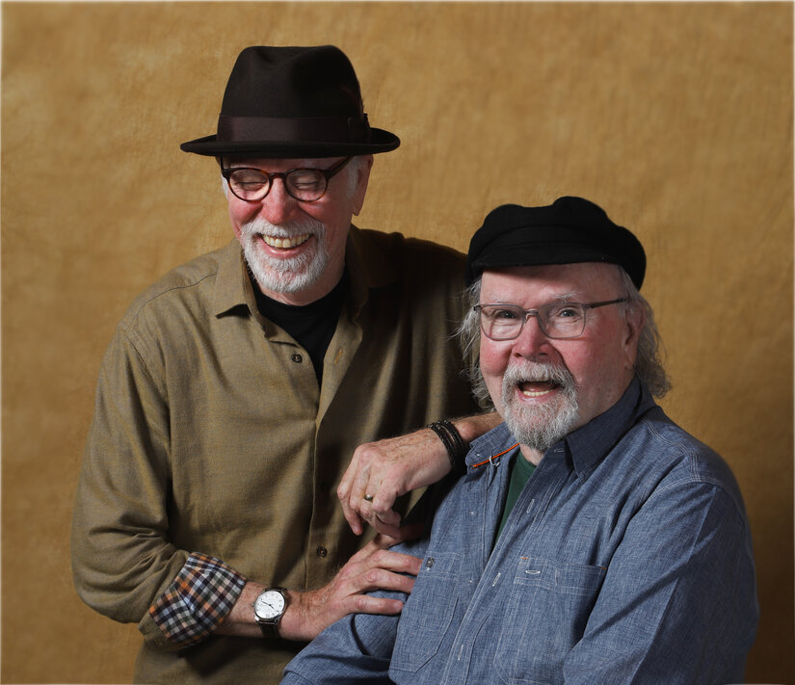

Folk music legends and dear friends get Together for their first joint album

John McCutcheon and Tom Paxton have been pals for decades, but it was COVID and Zoom that turned them into a songwriting team. Every Monday at 2PM they’d tell jokes, reminisce about old friends, and, of course, talk lots of sports. Eventually one would say, “Well, guess we better write a song, huh?” And off they’d go, two old warhorses pulling the plow. Now, a hundred songs later, they’ve gathered fourteen for their first joint recording, the aptly titled Together.

What happens when two of folk music’s most beloved and prolific songwriters join forces? Songs about history, the news, baseball, cowboys, America, love, the remembered, the forgotten. Gathering John’s familiar crew of supporting musicians (fiddle wizard Stuart Duncan, keyboardist Jon Carroll, bass player JT Brown, as well as special guest, Country Music Hall of Famer Charlie McCoy), the arrangements are compelling, the production pristine, and the performances stunning. From the stirring “Ukrainian Now” to the hilarious “Same Old Crap,” the immigrant story of “In America” to the heart stopping finale, “Together,” each song shines as would be expected of this partnership. (continues over)

Grammy Lifetime Achievement honoree Tom Paxton has been a force in the folk music world since the 1960’s, penning songs made famous by Peter, Paul, & Mary, the Kingston Trio, John Denver, Johnny Cash, Pete Seeger, Judy Collins, and more. His song “Last Thing on My Mind,” is “one of the best damn songs ever written,” declares McCutcheon.

John McCutcheon is a part of the generation of folksingers that grew up singing Tom Paxton songs. His own impressive catalog of songs spans forty-four albums, six Grammy nominations, numerous awards and accolades and the citing of his song “Christmas in the Trenches” as “one of the 100 essential folk songs,” by Folk Alley.

Together, they have seeded the folk music landscape with hundreds of songs, sung by thousands for decades. With the album Together, they add another bunch of great new ones to the repertoire of our time. And, given the bounty of those Monday afternoons, this is only the beginning.

1 | Ukrainian Now | 4:18
2 | This Campfire | 4:12
3 | Do the Work | 4:12
4 | Invisible Man | 3:42
5 | Same Old Crap | 3:13
6 | In America | 4:27
7 | Letters from Joe | 2:19
8 | The Fan | 4:35
9 | Complete | 2:45
10 | Everything | 1:17
11 | Life Before You | 3:51
12 | Christmas in the Desert | 4:09
13 | Prairie Star | 3:32
14 | Together | 3:24

Media contact:
Wendy Brynford-Jones
wendy@hellowendy.com
www.folkmusic.com – JM
www.tompaxton.com

